HORIZON FUN AT HOME
Sunday 26th April 2020
Hi Horizon fun parents. I have put together a short and hopefully easy to follow program for you to work through with your kids either on Sunday or in the week when it works best for you. I hope it is helpful. Have fun.
Emily x

FAITH IS ……………………………………..
At this tricky and interesting time our Faith in God and his promises to us are super valuable. But what is Faith?
The dictionary tells us that faith is:
Complete trust or confidence in someone or something.
God tells us that faith is:
Putting our confidence and hope in him.
Do you trust your parents? Lets see…………………….
Game:
Grownups, place a chair across the room or in a suitable place. Place a blindfold around your child’s face so that they cannot see. Tell your child that you will safely guide them across the room to sit on the chair. Spin child around a couple times then guide them to the chair.

Did you trust your parents? Did they get you safely to the chair, or were there some tricky moments?
When we listen to God and trust him to help us get where we are going, even if we don’t know where it is, we know that we will get there. This is Faith. Faith is believing, whole heartedly that God will answer our prayers, can heal the sick, can save our world!

Watch this story about faith: Jesus calms the storm
https://www.youtube.com/watch?v=uYLHqdSO9OY

Jesus wants us to have faith and to not doubt he is there. Bring to God your fears and worries and let him calm your storm.
With your child think about what you need prayer for and bring it faithfully to God.

Optional Craft: Sea sensory bottle
You will need:
Plastic water bottle or jar
Baby oil or other oil (results best with baby oil)
Blue food colour
Glitter (optional)

- ½ fill bottle with oil.
- If using glitter sprinkle some on top of the oil.
- In a jug mix water and food colour.
- Pour water until bottle is nearly, but not quite full.
- Place lid on bottle and seal with sellotape (or glue- hot glue gun if you happen to have one).

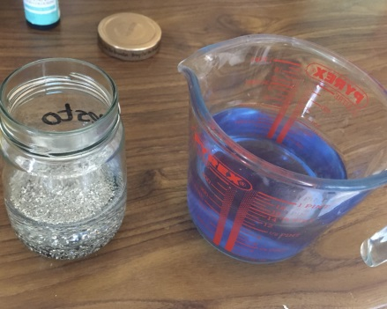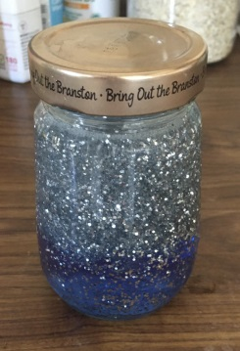
Use this bottle as a reminder to have faith in the storm

FOR A BIT OF FUN AND FEEL GOOD:
Pop on this song and dance it out!!!
https://www.youtube.com/watch?v=hNMMN46uFCc

